Network delay is high. What should I do?

User Scenario One:
Other people are downloading network resources(files/videos). Network delay is high when I am playing online games.

User Scenario Two:
Other people are watching video, Network delay is high when I am playing online games.

Solutions:

You can turn on QoS function to ensure smooth gaming and web browsing.

Step 1:
Open APP, tap “Settings” > “QoS”.

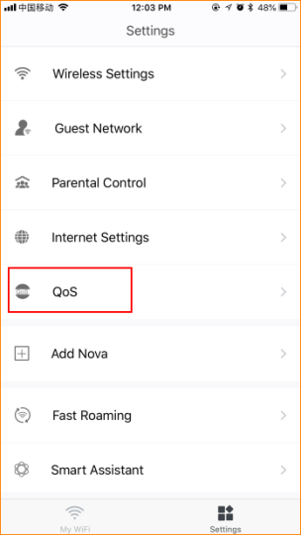

Step 2: Tap the QoS button to open the function.
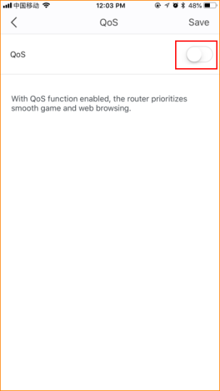

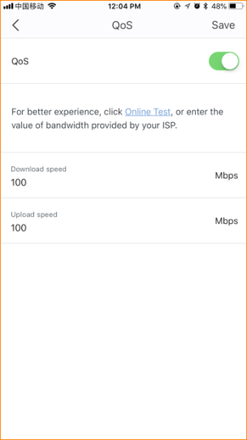

Step 3: Please enter reasonable download speed and upload speed. Then tap “Save”.

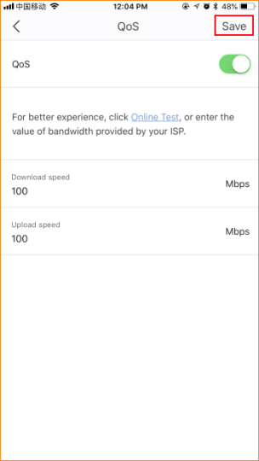

Note: If you do not know your bandwidth, please ask ISP for help.

